Rosé Torralbenc 2018

- Grape varieties: Monastrel and Merlot
- Alcohol: 12 % vol.

The Monastrell vines are cultivated to produce a fresh and aromatic rosé wine.

  - The grapes of the Monastrell variety form the basis of this unique wine, the reason for its structure and expression.

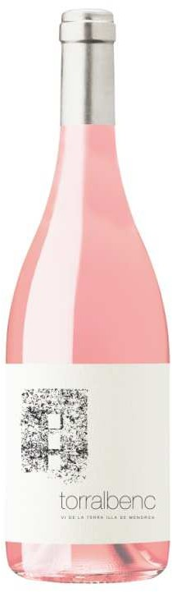
Its colour, clean and bright, is of an attractive pale pink.

The nose presents highly intense aromas, with highlights of floral hints such as roses; citrus fruits such as orange skins, grapefruits, nectarines; red fruits, especially strawberries, cherries and blueberries. Balsamic aromas can also be found, which are present in Mediterranean plants such as fennel.

In the mouth, it is a finesse rosé, with a very good volume, an outstanding and pleasant freshness; an end result of a long aftertaste of fresh fruits and citrus. It displays a well-defined minerality.

The whole is singular, fresh and has a very attractive balance.

